Setting up GitHub Account

Step 1:

Visit GitHub website and click on sign up

Below interface will be shown

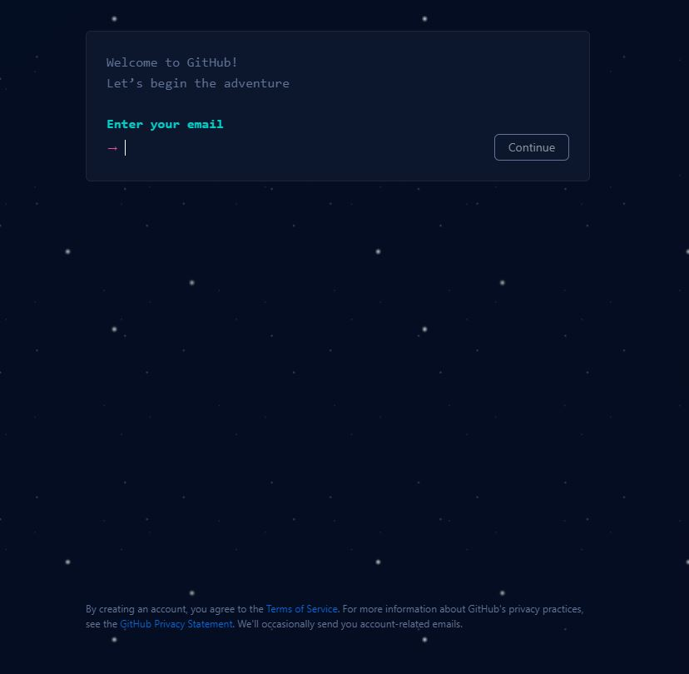

Step 2:

Enter your email address and create password

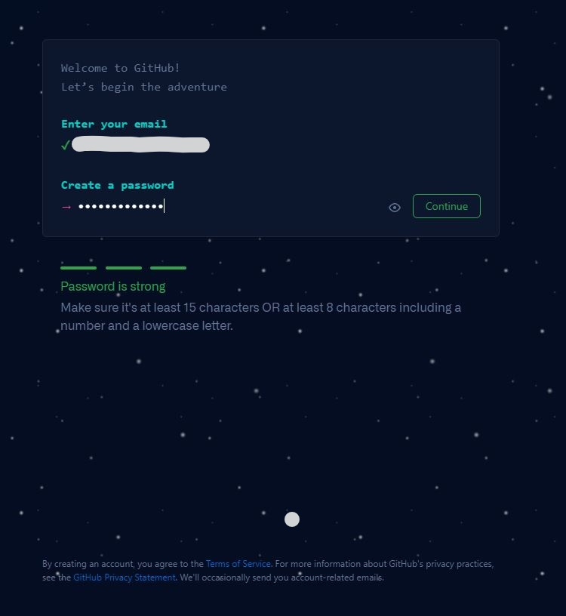

Step 3:

Give unique username

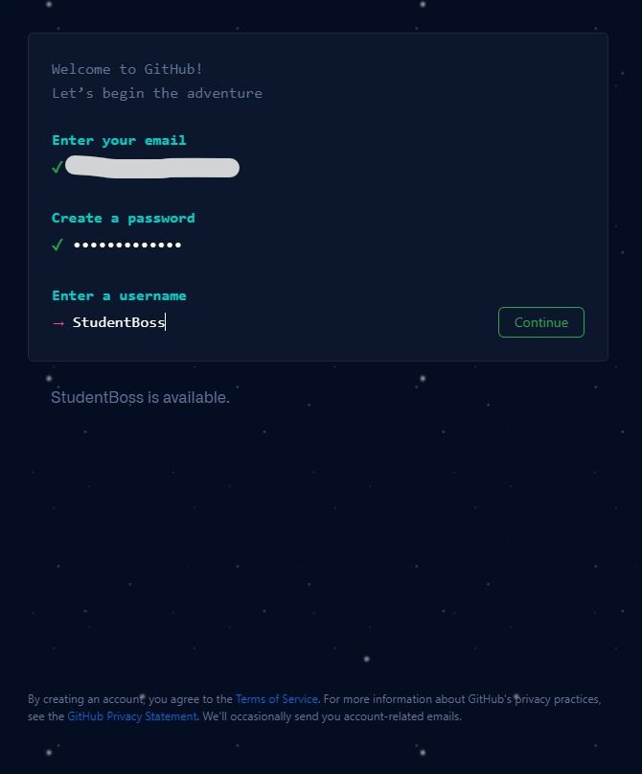

Write y or n in double coutes

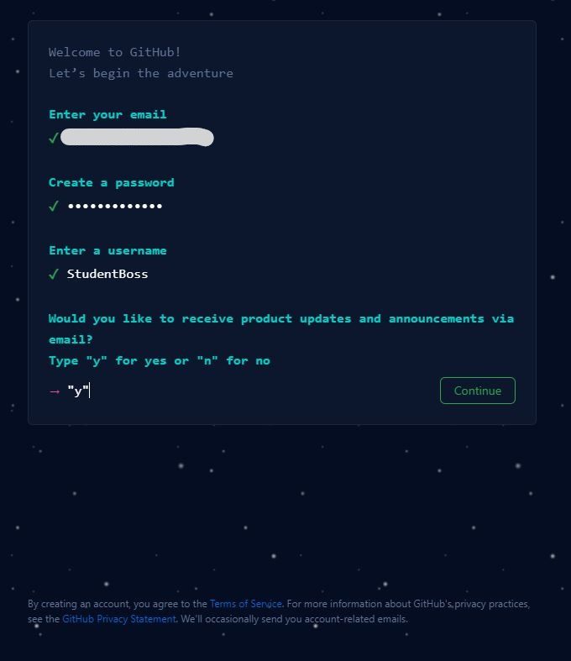

Step 4:

Verify your account

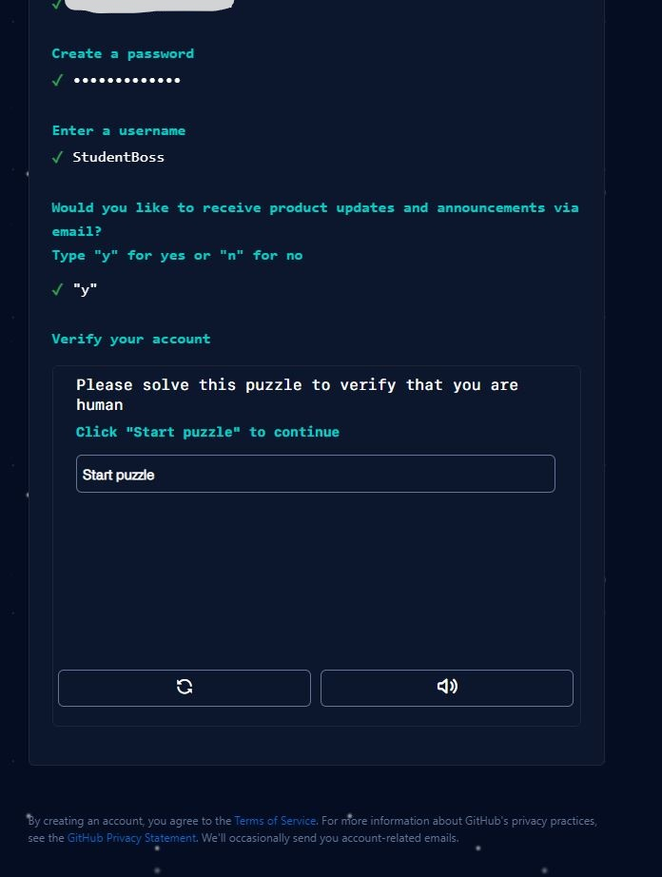

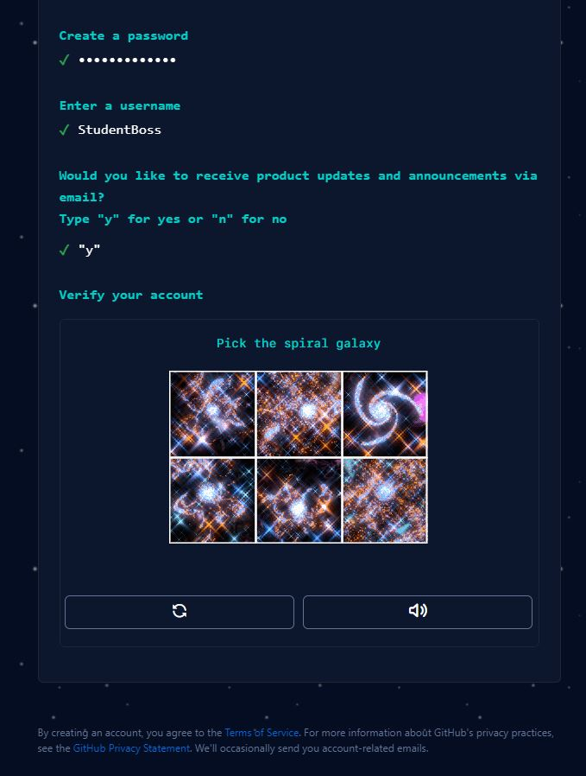

Step 5:

Click on create account. You are ready to go

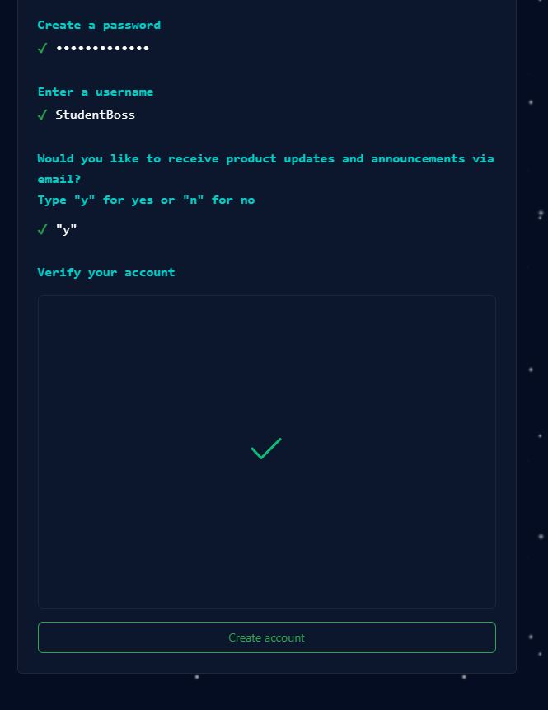

Step 6:

Do email verification.